ASSIGNMENT 2.5

2303A51574

BATCH-29

Task 1: Refactoring Odd/Even Logic (List Version)
❖ Scenario:
You are improving legacy code.
❖ Task:
Write a program to calculate the sum of odd and even numbers in a list,
then refactor it using AI.

CODE:
def sum_odd_even(numbers):
odd_sum = 0
even_sum = 0

for num in numbers:
if num % 2 == 0:
even_sum += num
else:
odd_sum += num

return odd_sum, even_sum

# Example usage
numbers = [1, 2, 3, 4, 5, 6, 7, 8, 9, 10]
odd_sum, even_sum = sum_odd_even(numbers)
print(f"Odd sum: {odd_sum}")
print(f"Even sum: {even_sum}")

OUTPUT:
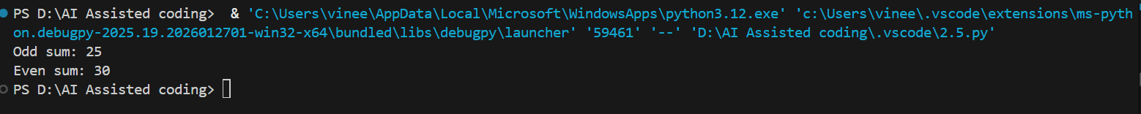

Task 2: Area Calculation Explanation
❖ Scenario:
You are onboarding a junior developer.
❖ Task:
Ask Gemini to explain a function that calculates the area of different
shapes.

CODE:
import math

def calculate_area(shape, **dimensions):
shape = shape.lower()

if shape == "circle":
# Formula: πr²
return math.pi * (dimensions['radius'] ** 2)

elif shape == "rectangle":
# Formula: length * width
return dimensions['length'] * dimensions['width']

elif shape == "triangle":
# Formula: 0.5 * base * height
return 0.5 * dimensions['base'] * dimensions['height']

else:
return "Shape not supported."

# usage
print(calculate_area("circle", radius=5))
print(calculate_area("rectangle", length=10, width=4))

OUTPUT:
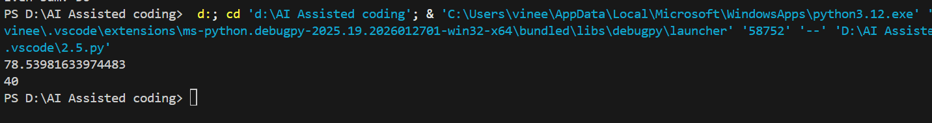

Task 3: Prompt Sensitivity Experiment
❖ Scenario:
You are testing how AI responds to different prompts.
❖ Task:
Use Cursor AI with different prompts for the same problem and observe
code changes.

CODE:
# Problem: Calculate the sum of numbers in a list

# Prompt 1: "Write a function to sum numbers"
def sum_numbers_v1(numbers):
total = 0
for num in numbers:
total += num
return total

# Prompt 2: "Write a concise function to sum numbers"
def sum_numbers_v2(numbers):
return sum(numbers)

# Prompt 3: "Write a function to sum numbers with error handling"
def sum_numbers_v3(numbers):
try:
if not isinstance(numbers, (list, tuple)):
raise TypeError("Input must be a list or tuple")
return sum(numbers)
except TypeError as e:
print(f"Error: {e}")
return None

# Prompt 4: "Write a function to sum numbers using recursion"
def sum_numbers_v4(numbers):
if len(numbers) == 0:
return 0
return numbers[0] + sum_numbers_v4(numbers[1:])

# Test all versions
if __name__ == "__main__":
test_list = [1, 2, 3, 4, 5]
print(f"v1: {sum_numbers_v1(test_list)}")
print(f"v2: {sum_numbers_v2(test_list)}")
print(f"v3: {sum_numbers_v3(test_list)}")
print(f"v4: {sum_numbers_v4(test_list)}")

OUTPUT:
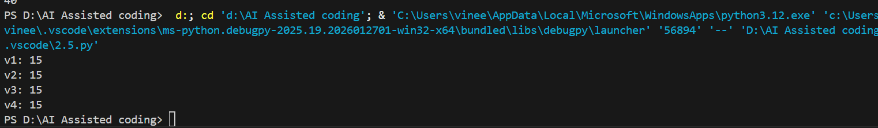

Task 4: Tool Comparison Reflection
❖ Scenario:
You must recommend an AI coding tool.
❖ Task:
Based on your work in this topic, compare Gemini, Copilot, and Cursor AI
for usability and code quality.

SOLUTION:
Feature | Gemini Code Assist | GitHub Copilot | Cursor AI
Primary Strength | Large context (2M+ tokens) & GCP integration. | Reliability & seamless workflow. | Agentic multi-file refactoring.
Usability | Plugin-based; best if you use Google Cloud/Firebase. | Native to VS Code/JetBrains; "set it and forget it." | Standalone IDE (VS Code fork); requires migrating editors.
Code Quality | High quality for architectural logic & explanations. | Excellent for boilerplate & standard libraries (97% accuracy). | Superior for complex logic & cross-file consistency.
Unique Feature | Citations for suggested code; deep documentation search. | Workspace (Issue-to-PR) & Enterprise governance. | "Composer" mode for background agentic coding.

